6.5.11 Search Activity –Searching for Ghee in the Traditional Knowledge Digital Library (TKDL)

Ghee is a class of clarified butter that originated in South Asia and is commonly used in South Asian (Indian, Bangladeshi, Nepali, Sri Lankan, and Pakistani) cuisine and ritual. There is a vast amount of traditional knowledge concerning “ghee”.
Go to the TKDL site at:
http://www.tkdl.res.in/tkdl/langdefault/common/Global_Search.asp?GL=Eng
and find out
- How many records there are where “ghee” is an ingredient
- Some of the diseases for which “ghee” in combination with other ingredients is considered effective.
- Some of the IPC symbols applied
- How far back the knowledge contained in the oldest record extends.

Model Answer
Using the advance search feature, enter ghee in the keyword search box.
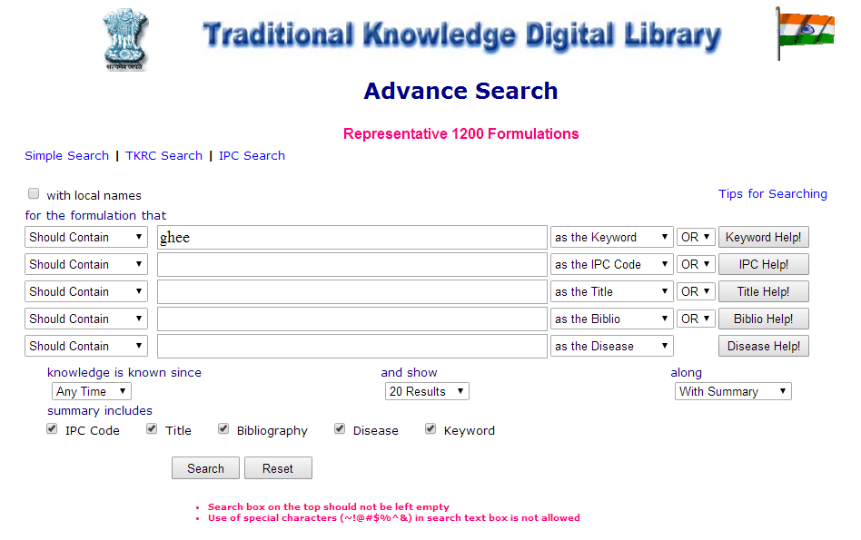

a) We get 17 hits:
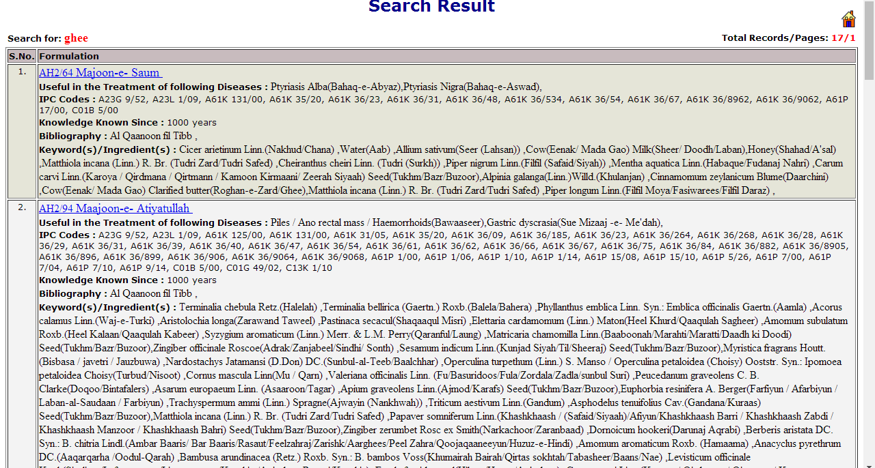

b) Some of the diseases are: headache, constipation, cough, diarrhoea, amnesia, paralysis, epilepsy, etc.

c) Some of the IPC symbolscodes are: A61K 125/00, A23C 15/00, A61P 29/00, A61K 36/9068, A61K 36/481, etc.

d) The knowledge in the following four records goes back over a thousand years
  - JA3/53 Hadeed
  - AH2/94 Maajoon-e- Atiyatullah
  - AH2/99 Majoon-e- Lanaa
  - AH2/64 Majoon-e- Saum

